**Lab - Performing a Full Backup and Recovery of Server 2012 R2**

**Overview**

In this lab, students will learn to install the Windows Server Backup role and perform a full system backup and recovery.

**Requirements**

Students will need to first complete the lab for adding one additional hard disk to their Server 2012 R2 virtual machine. This will be used as the backup volume.

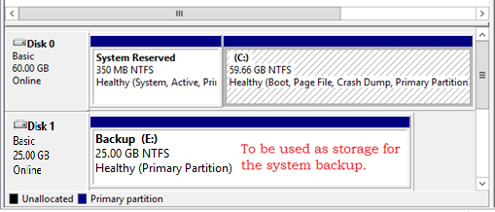

Log into your Server 2012 R2 virtual machine. Once Server Manager starts up, go to Manage and select Add Roles and Features.

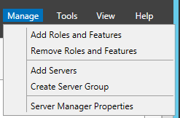

Select Role-based or feature-based installation.

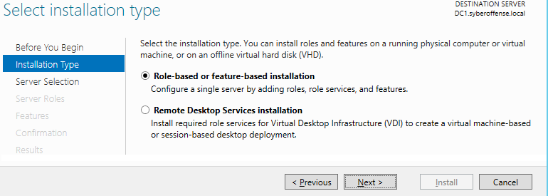

Select the server for your server pool.

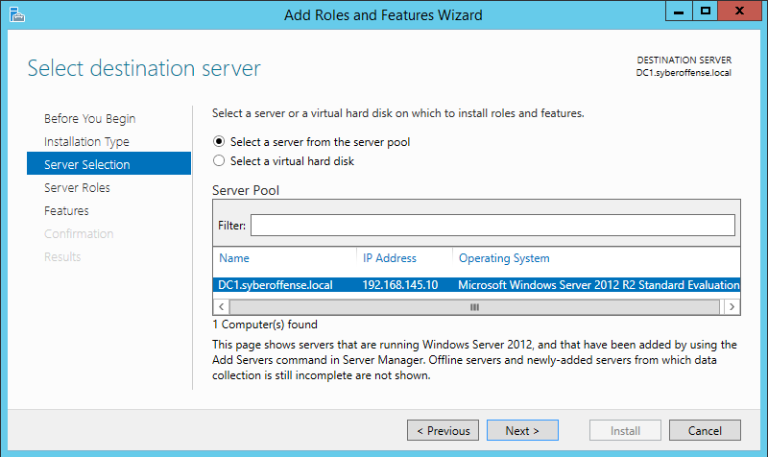

On the roles selection page, click next (no section here).

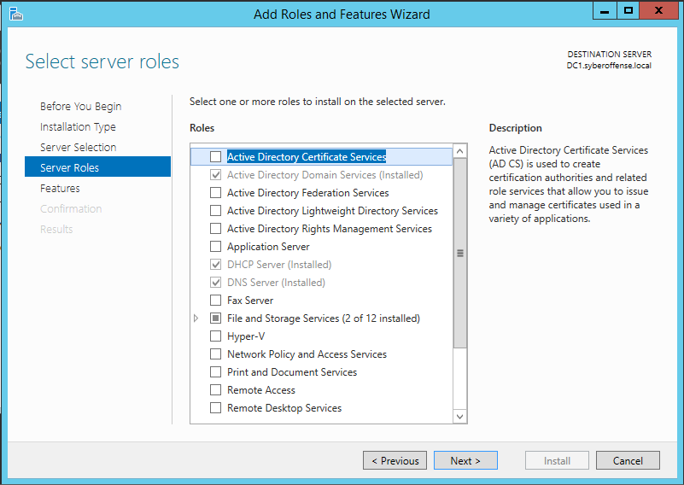

On the features page, scroll down to the Windows Server Backup feature, select the box and click next.

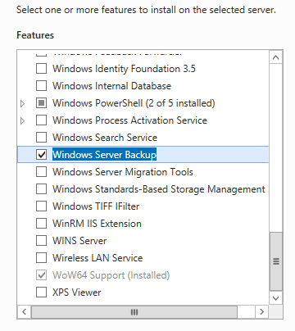

Confirm your selection and click install.

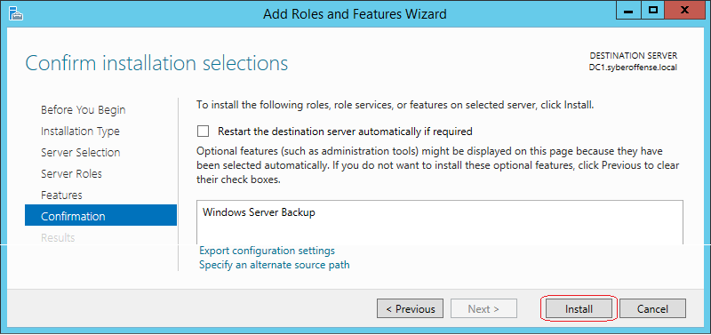

Allow the install to complete and click on close.

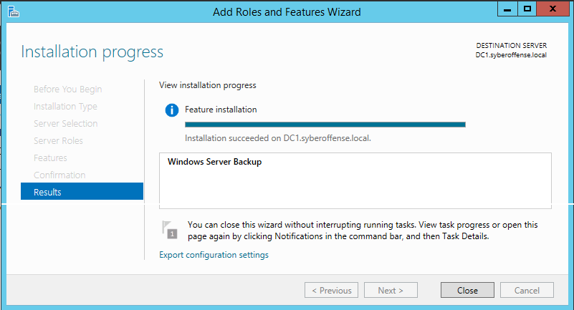

Back at Server Manager, click on tools, scroll to the boom of the list and click on Windows Server Backup.

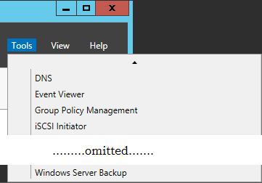

From the left window pane select, **local backup** and from the taskbar, click on **Action** and from the context menu select **Backup Schedule**.

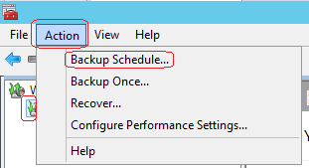

On the **Getting Started** screen, click next.

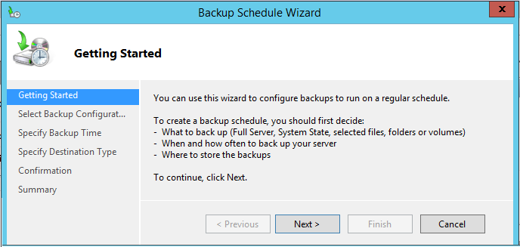

On the page accept the defaults and click next.

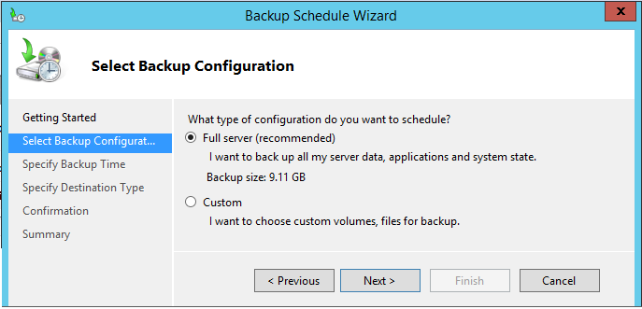

On the Specific Backup Time, Enter the time to begin the backup. This would normally be when there is little activity on the network or the server is having a major change to its hardware or software.

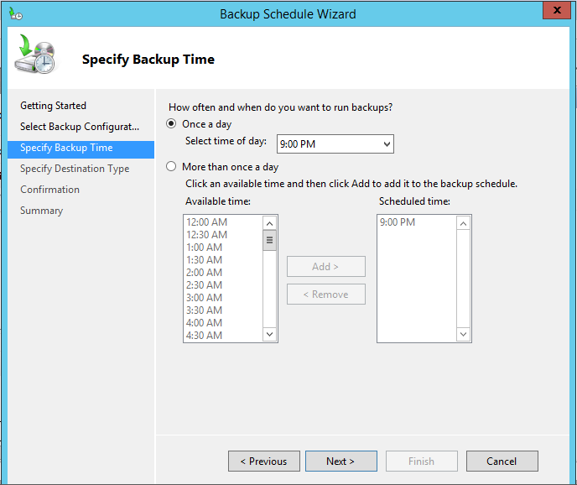

On the Specify Destination Type, select Backup up to a hard disk that is dedicated for backups. Click Next,

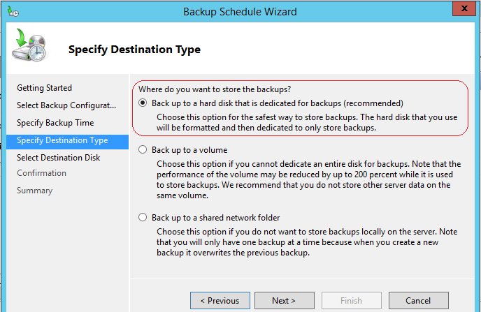

On the next page, click on Show Available Disks. Under available disk check the box for Disk 1. Click next.

If you get the following warning, click OK. Window Backup must format the volume so that is can be used as the designated backup.

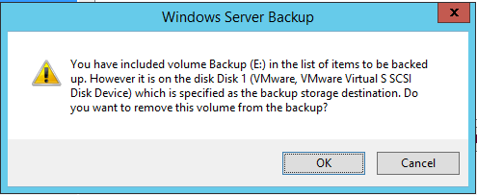

Click yes on the next warning message.

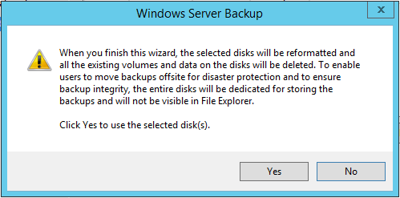

Windows Backup quickly performs a backup. On the next window, click **Finish**.

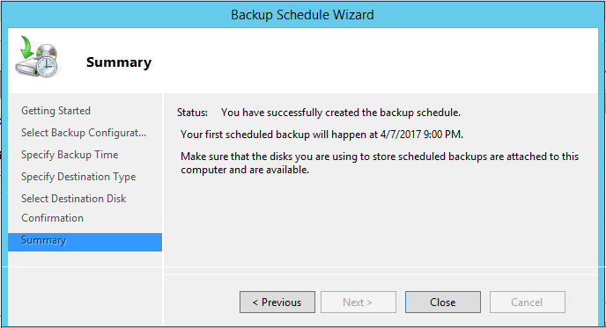

Open Computer Management and launch your Disk Management tool. Look at the 10GB disk created early. It now shows as a backup disk for the server. Note the time stamp of the last full backup. This will change with each backup.

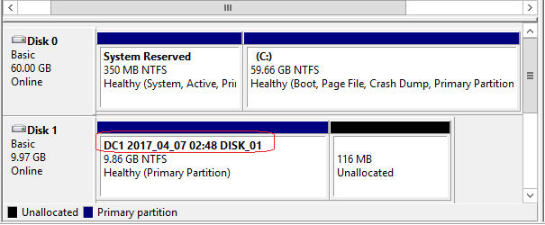

End of the lab!